Alyssa Liu

EECS 397

1/14/17

**Ch 1-2 Exercises**

**Chapter 1**

1. **Nouns and verbs –** [**Katamari Damacy (2004)**](https://en.wikipedia.org/wiki/Katamari_Damacy)
   1. **Nouns** – katamari (a large bumpy sphere), world objects (e.g. stationery, food, animals, people, household goods, plants, vehicles, buildings), stars, constellations, timer

**Verbs** – rolling the katamari around, rolling up objects onto the katamari, bumping into bigger obstacles, charging with the katamari

* 1. **Gameplay** – the player rolls a katamari around on Earth to pick up objects. By picking up objects, the katamari grows bigger and can thus roll up bigger objects. The goal is to get the katamari to a certain size or to pick up as many of a certain item as possible within a time limit. These katamaris get cast into the sky as new stars and constellations (previously wiped out by the player character’s father).
  2. **Experience** – The game is enjoyable because it is exciting to try to complete challenges presented to you. It is very satisfying to start from a very small katamari to being able to roll up large objects and even animals or people. The game world can be tricky to navigate, especially when the katamari is small, but overcoming this is very enjoyable. Replaying levels and creating even bigger stars is also fun because you get to best your personal records.

1. **Elements outside the model**
   1. (**visual design**) The visual style of the game is very pleasing to me. I love the vibrant yet not over-the-top colors and the low-poly geometry. I really like how the game world is cluttered with objects to be picked up – the art style is very nostalgic to me.
   2. (**music/sound design**) The soundtrack of the game is very catchy and memorable. The songs themselves talk about katamari and are strongly influenced by past eras of Japanese pop as well as jazz. It also spans a wide range of emotions, from energetic to introspective. I also think the sound effects, particularly when the player bumps into obstacles, are very playful, which adds even more humor to the game.
   3. (**story**) Completing levels unlocks new cut scenes that unfold a very wacky storyline. These tidbits are very entertaining and serve as a fun reward for your accomplishments. Since each leaves off on a bit of a cliffhanger, players are motivated to keep playing to learn more about what happens in the story.
   4. (**context/setting**) The overall premise of the game is nothing like what I have seen before. Your father, the King of the Cosmos, has accidentally wiped out the stars in the sky and as the tiny Prince, you are sent to Earth with katamaris to roll up Earth-objects into replacement stars and constellations. This setting is very whimsical and quirky, which makes the game exciting and very fun to me.
   5. (**user interface**) The UI is not only whimsical, adding to the game’s visual aesthetics, but is also very helpful for players. There is a clear diagram in the top left corner depicting how big the katamari currently is compared to the goal size. On the top right corner is a timer indicating how much time you have left. The bottom left corner depicts the last item rolled up by the katamari. Finally, the bottom right depicts the player’s character, the Prince, as it is running around pushing the katamari (most of the time the katamari is too big so the player is not very visible).

**Chapter 2**

1. **Experience is relative –** [**Neko Atsume (Cat Collecting)**](https://en.wikipedia.org/wiki/Neko_Atsume)
   1. I enjoy Neko Atsume because the visuals are very simple yet cute. I also like how I can unwind and relax while playing it. I grew up with pets so this is a silly way to have pets, in a way. The premise is interesting to me as well – you set up a space with toys and food and wait for cats to visit you. I love the surprise of discovering and “collecting” new cats when you open the app.
   2. One aspect of the game I enjoy a lot is being able to customize the space. I love having the freedom to create whatever space I can imagine by purchasing and arranging toys, furniture, and treats for the cats. Other people may not be interested at all in investing this much time designing a new “world” for the cats. I also really like taking the time to collect new cats and looking in the photo album of cats that have visited. This is not something everyone would enjoy, either.
   3. Other players might enjoy challenging themselves to collect as many cats and buy every available item as soon as possible. However, I am not as competitive or speed-oriented. I like taking my time with the game and focusing on relaxing by playing it, rather than on completing it as soon as possible.
2. **Designer models –** [**Super Smash Bros Melee**](https://en.wikipedia.org/wiki/Super_Smash_Bros._Melee)
   1. From my experience with this game, I can see players fitting into the various categories of the Bartle model. Achievers may be motivated to unlock new characters or stages. Killers could be motivated by winning over their opponents and placing first after a round or tournament. Explorers might be interested in trying new characters and learning their various strengths, weaknesses, and combos. Socializers may be motivated by the interactions and bonds they have with their teammates or opponents. Taking part in the strong community that has grown around this franchise could also motivate socializers. In this game, I find myself to fit both as a Killer and as an Explorer. I am motivated to win matches but am also very curious about trying new characters and learning them.
3. **User personas –** [**Neko Atsume**](https://en.wikipedia.org/wiki/Neko_Atsume)
   1. High school student – A female high school student who is very stressed from school. She plays Neko Atsume to destress and relax after classes. Seeing the cute cats helps her unwind.
   2. College student – A male college student who has two cats at home. He misses having his pets during the school year so he enjoys collecting the cats in his game. He plays regularly because he is trying to collect all of the cats available.
   3. Recent graduate – A female college grad who likes to play the game during lunch or after work to relax and take her mind off of work. She loves decorating and customizing the cats’ space and sometimes shares them with her friends and coworkers who also play.
   4. Mom – A stay at home mom who likes having a casual, lighthearted game to play between errands or during the day. She plays also to stay connected with her daughter who plays the game.
4. **Yee model**
   1. The 4 motivations under Immersion (fantasy, story) and Creativity (design, discovery) best reflect my personal motivations in games. In particular, I enjoy story, discovery, and design. I find myself to be indifferent to completion, challenge, and strategy. While I can enjoy these things, I do not actively look for them in games. However, I am not very inclined towards games where competition, community, power, or excitement. I tend to avoid games that rely too heavily on social interactions or are very intense and fast-paced.
   2. My survey results were very closely matched to my expectations. I think the model describes very well the games I like to play.

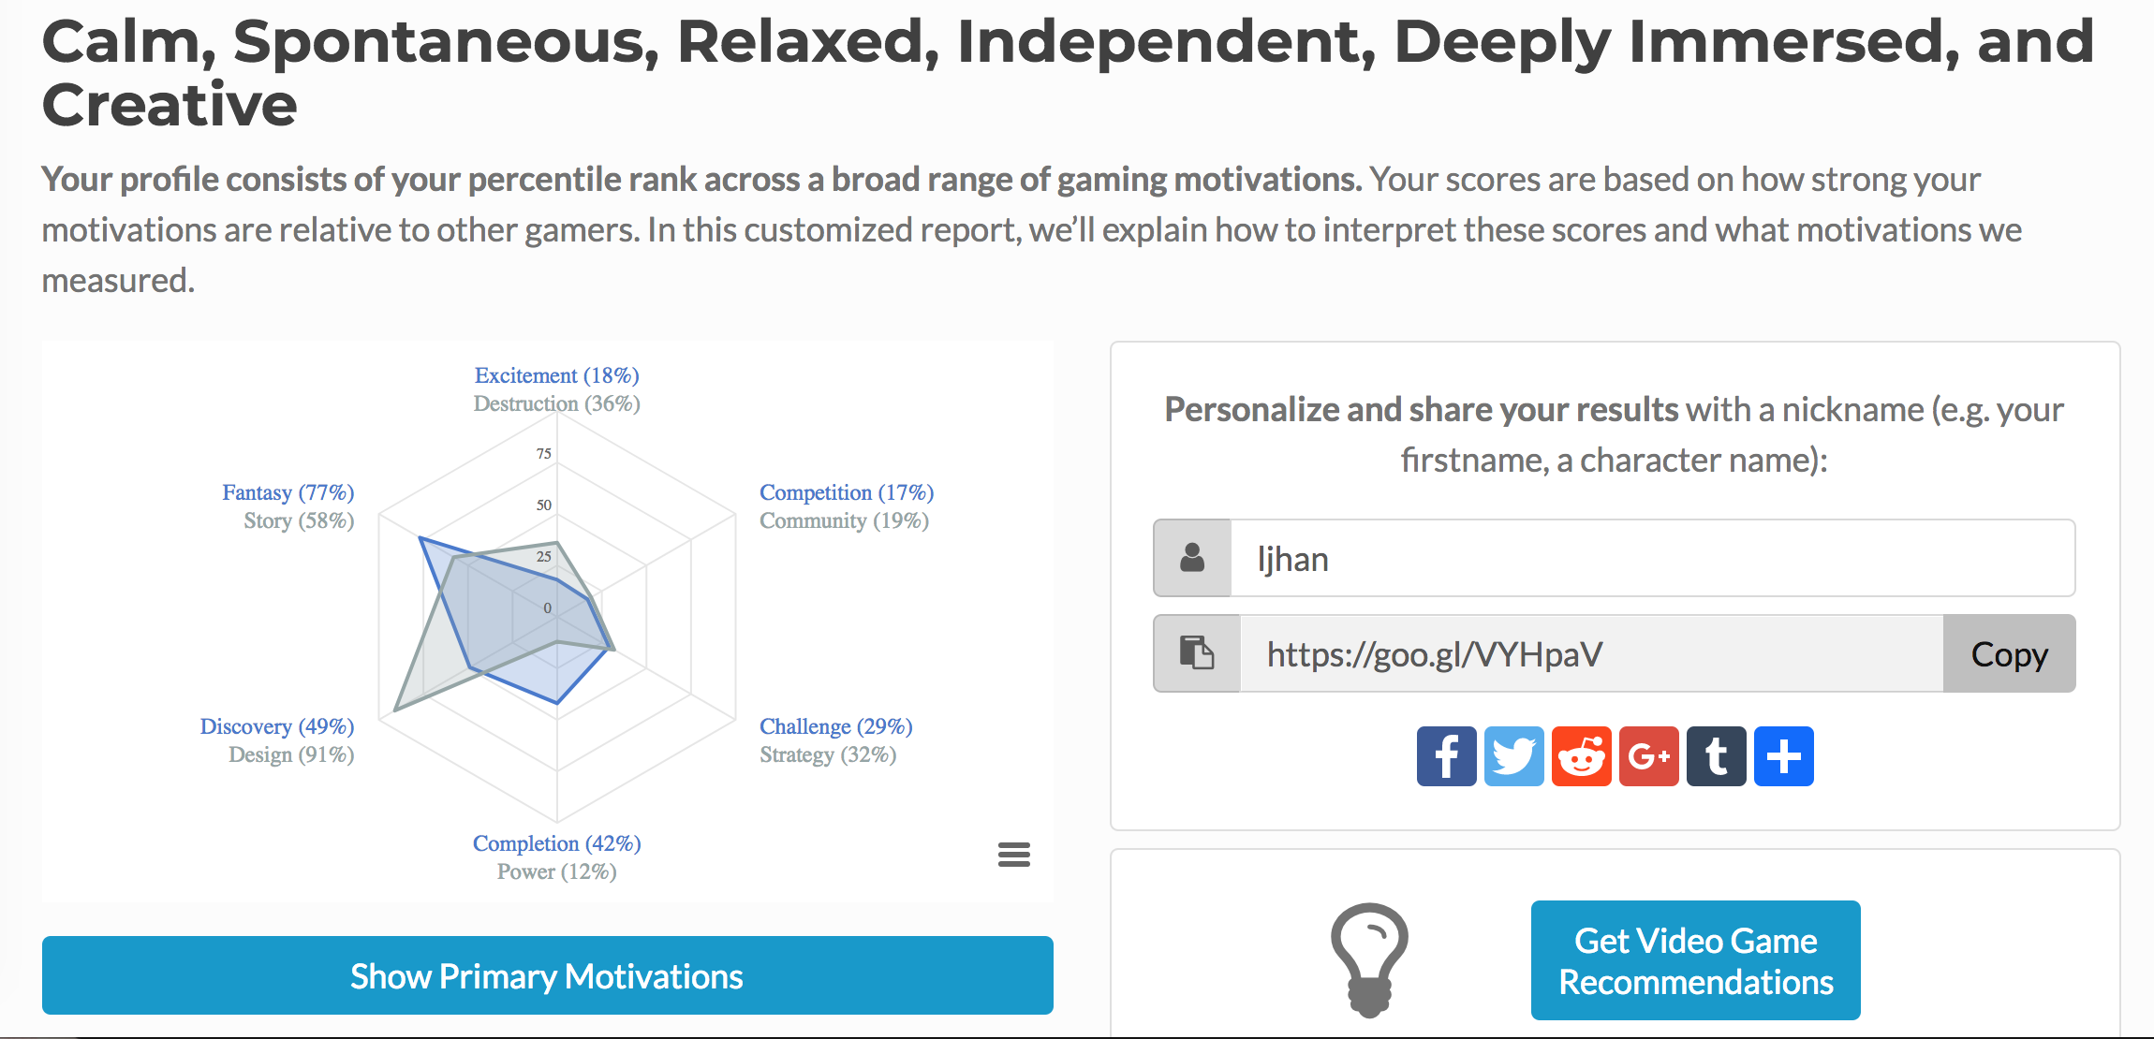

The results depict that I am very motivated by the Immersion and Creativity motivations. However, I am not inclined toward excitement, competition, power, or community. I also really liked the summary description from the survey – I think it captures the games I like really well. I like relaxing games where I can be immersed in a story or world by myself. I also really enjoy some surprises and the freedom to be creative.

1. **Questions to guide design –** [**Cooking Mama**](https://en.wikipedia.org/wiki/Cooking_Mama)
   1. People who enjoy cooking, as well as people who enjoy challenges under a time pressure and trying to best their achievements in various stages.
   2. Players will enjoy being able to experience a wide range of recipes and cuisines by playing the game. The time pressure throughout gameplay can also be exciting for players. Also, they may enjoy the opportunity to continue improving their scores and achievements for the various recipes. Some players may enjoy the feeling of completing all the recipes with gold medal achievements.
   3. A forum or wiki including tips on recipes as well as perhaps information about all unlockable recipes may be enjoyed by players. Players really interested in the culinary aspect of the game may even enjoy a real life cookbook of the recipes depicted in the game.
   4. [**Dishonored**](https://en.wikipedia.org/wiki/Dishonored) – The game appeals to players who enjoy a lot of explicit action, players who prefer more subdued action, as well as players who enjoy working through a plot that evolves based on the choices the player makes. The game successfully satisfies many different player motivations. The player’s ability to assassinate characters fulfills the Action motivations of destruction and excitement. Meanwhile, there is a well-developed story that unfolds as the player progresses through the game, satisfying that Immersion motivation. Furthermore, there is the option to play using magic, which – along with playing in the role of an interesting character – satisfies the motivation of fantasy.
2. **Experience archetypes and genres**
   1. **Interactive Fiction** – The most obvious player motivation fulfilled by this genre is story. In addition, many IF games allow players to assume a novel role, which satisfies the motivation for fantasy. Typically, the goal is to get through the entire plot, so completion is involved as well. In many IFs, players can explore the game world, which touches upon discovery. However, motivations such as challenge, competition, and community are not particularly emphasized in the genre. IFs are usually played and experienced individually, and there are not usually ways you can practice in preparation for difficult challenges.
   2. [**Katamari Damacy**](https://en.wikipedia.org/wiki/Katamari_Damacy) – This game is marketed as a puzzle action game. However, it satisfies player motivations regarding action more than it does for puzzle. While there is a lot of action in the game: physically moving the katamari, navigating the game world, colliding with obstacles and breaking the katamari, and causing chaos by rolling up people and buildings. However, the puzzle elements are subtler. Players have to be strategic about when to roll what sized objects, figure out how to navigate obstacles in the game world, and come up with a plan for optimizing katamari growth. However, strategy (puzzle) is not as emphasized in the game as destruction and excitement (action) are. Success in the game is more driven by the action-related components than it is by the puzzle-related elements. While the game continuously satisfies players’ motivations for destruction and excitement, it does not always satisfy the challenge and strategy typically satisfied by puzzle games. It is very possible to clear levels by brute force and without much planning or strategizing.